Problem Definition

Jamaica Public Service (JPS) currently pays out millions of dollars each year for wrongful disconnection (they paid out approximately $140 million in 2010 for breaches). Each parish officer generates the disconnection list the day after the customer bill is due, that list which comprises of approximately 5000 disconnection orders is then passed on to the disconnection contractors. There are no checks of the customer credit worthiness, payment history/payment method, if it’s a special needs customer etc. If checks are to be done it would be a manual process, the company does not have the resources to check each customer on the disconnection list. Based on revised laws the company must automatically compensate residential customers $3000 and commercial customers 5 times the applicable service charge if they are wrongfully. JPS has approximately 600,000 residential and commercial customers. For wrongful disconnection the company would have to pay the contractor twice (for disconnection and reconnection of service). A customer account may appear to be overdue if they use some online payment facility other than *MyJPS* or JPS telephone bill payment; these other payment facility normally take 24 to 48 hours to transfer payment to JPS. If a customer’s service is wrongfully disconnected the service must be restored within five hours, these constraints are set out in the JPS Guarantee Service Standards 2009-2011which is monitored and enforced by the Office of Utilities Regulation (OUR).

Solution

A web based Decision Support System (DSS) that will assist JPS to reduce wrongful disconnection by using data mining technologies to develop customer profiles (customer payment history, payment method, type of customer, location etc). When the disconnection list is produced it will be passed through the DSS to rank customers and make recommendations as to which customers’ disconnection orders should be issued for and which customers’ reminders should be sent to. The option for customers to either text or enter into a web interface the invoice number and amount if they have already paid using some online medium such as paymaster etc. would also be a feature of this system.

**Architecture**

Data Mining Process-CRISP-DM

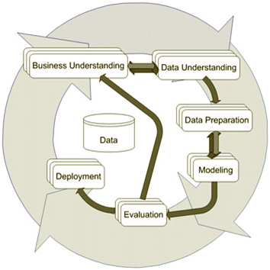

System Design/Architecture

Client Tire Application Tire DB Tire

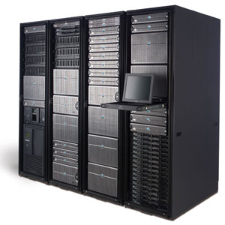





*SQL Server*

*Technical Elements*

*ASP.NET*

*IIS Server*

*Java Script*

*Or*

*PHP*

*HTML*

***Browsers eg:***

*Internet Explorer*

*Firefox*

*Chrome*

Utility Decision Support System (DDSS)

Internal Process of Architecture

Disconnection List Rule Base Algorithm

Decision support system Expert recommendations

**System Functional Requirements**

1. **System Security & Control**

The security features of the system will be control by access level,

restricting users to functions specific to their role and privileges. In order

of highest functionality will be:

Administrators: All functions of the users below and system maintenance

Supervisor All functions of system except maintenance, update data base tables, view reports, create user accounts, reset user password

Parish Officers All function of system except maintenance, update data base tables, view reports

1. **Reporting**

Search database for individual customer by name or customer #,

View list of bad customer and good customer

Dynamic dashboard reporting of disconnection order prepared vs disconnection order on hold

1. **Administration**

**View list of:**

1. Customers who disconnection orders will be prepared for
2. Customers who disconnection orders should be put on hold

Print reports and export the processed list

1. **Decision Support**

Automatically process the disconnection list

Make recommendations to decision makers

**Database Key**

**Rate:** the classification of the customer  
10 - Residential  
20 - Small commercial  
40 - Large commercial  
  
**Due Date:** the date the bill was due to be paid  
**Special:** customer identified as "Special Needs" ie life support at  
location, hospital or some other similar location  
**Discon Order:** this account was disconnected for non-payment  
**Premise:** the code number for the location that is being metered by JPS  
**Customer:** the code number for the customer who is billed for the location  
that is being metered  
  
Premises + Customer combined = account number

Data Base Fields

|  |  |  |  |
| --- | --- | --- | --- |
| Field Name | Field Type |  | |
| Last Name | Char |  | |
| First Name | Char |  | |
| Premise | Int |  | |
| Customer | Int |  | |
| Rate | Int |  | |
| Account # | Int |  | |
| Due Date |  |  | |
| Amount Due |  |  | |
| Disconnect Order |  |  | |
| Special |  |  | |
| Payment History Ranking |  |  | |
|  |  | |  |

**Rules**

**Rules from Expert**

1. **Customer service should not be disconnected if their account is under investigations by Office of utilities Regulation (OUR)**
2. **Customer account is not over due**
3. **Company and only the disputed amount is in arrears**
4. **If the amount owing is less than $1,500**
5. **If customer is classified as Special**

**Rules from SAS Data Mining**